**Timesheet Guidelines & FAQ**

1. **Use of Support & TTITO PIDs** - **always be non-billable**

* Below two PID default appear to all Enquero employees—

TTITO-Oracle PID -91531670

Support Operations-Oracle PID 91525570

* **TTITO PID -91531670—For Holiday/Bench/Leave**
* Public Holiday select task code 06.02
* Bench time – select task code 06.07
* Travel & leave select relevant code from below list
* **Support PID-91525570—Used for support team who are engaged in non-billable internal project like if team is working on Power ME**

Below is task code available – Internal Project team can select 06.13 task code

|  |  |
| --- | --- |
| **TTITO-Oracle PID -91531670** | **Support Operations-Oracle PID 91525570** |
| 06.01 Training Time | 06 Time/Allocation |
| 06.02 Public Holiday | 06.04 People Management |
| 06.03 Business Travel | 6.08 Idle Time (NB) |
| 06.04 Sick Leave | 6.09 Dashboards & reports |
| 06.05 Annual Leave | 06.10 Project Panels |
| 06.06 Casual Leave | 06.11 Leave/Holiday |
| 06.07 Idle Time | 06.13 IP Creation (White Papers) |
|  | * 1. raining Time (NB) |

If any User **still doesn’t** have Support & TTITO PID – pls drop mail to below USERS

Chakraborty, Soham:-soham.chakraborty@genpact.com

Genpact Genpace Support [genpactgenpacesupport@genpact.com](mailto:genpactgenpacesupport@genpact.com)

1. **How do I see my billable project whom I need to connect?**

**Expectation from Resources**

* First check with your supervisor or PM – are you on billable project
* IF non billable – On support pls fill timesheet in Support role PID
* If on bench: - pls fill timesheet in TTITO PID per above
* **If Billable project** – it will auto reflect in OTL once allocation done no need to connect anyone here
* If billable project is not appearing what to do; - **Pls refer Point E below**

1. **Billable project pls select task code 06.01- Regular**
2. **Team is getting below error due to non-selection of task code**

**Reason**

* User has not selected task code
* User has selected wrong task code

**Expectation from Resources**

* Please don’t submit timesheet without task code
* Please select correct timesheet as per detail already shared in above point A & B

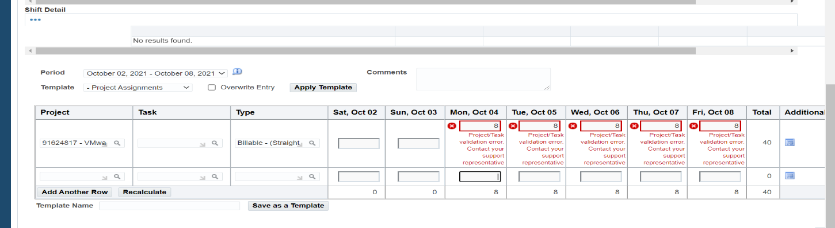

1. **Team is getting below error due to resource allocation is still pending to update from backend.**

**Reason for pending allocation**: -

* Extension Document pending
* Billing team needs some clarification on docs shared
* Document shared its under process so need typically 1 working day to start reflecting in OTL system

**Expectation from Resources**

* Resource should wait until last day of timesheet and if still not available
* Fill timesheet under Support PID for the time being
* Timesheet team will do require correction to correct Project ID once its available based on input from PM

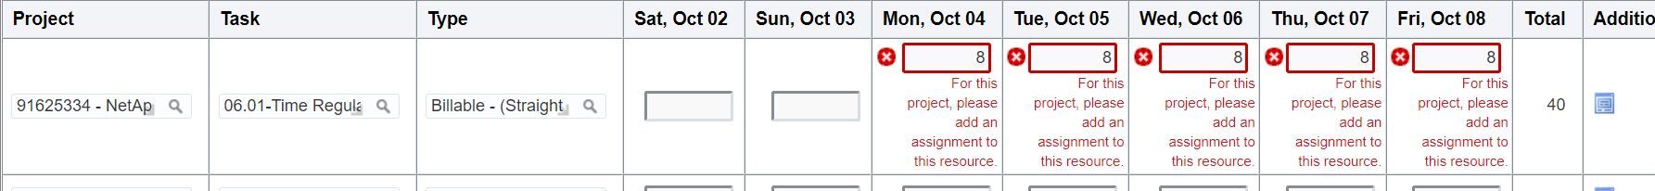

1. **Error message of Previous week timesheet not yet submitted – message while submission**

* Getting message that previous week (1st oct 21) timesheet is not yet submitted – Please ignore this message and submit your timesheet.

1. **Resources working on Project like below License projects, or any other internal project** are supposed to fill timesheet under **support PID Oracle PID 91525570** with task code 06.13 (Please *note except those resources who are specially aligned on this project with bill rate like in first project CISPA22PM  3 resources are aligned Jagruth/Ravi & Venkat – these resources would continue fill timesheet in PID 91625777 with task code 06.01 only)--*

|  |  |  |  |  |
| --- | --- | --- | --- | --- |
| 91625777 | CISPA22PM | 91625777 | Cisco Systems Inc | Cisco PowerMe License |
| 91625558 | DRIITPOWL | 91625558 | Driscoll's, Inc | PowerMe License |
| 91625343 | EQUITLEAP | 91625343 | Equinix, Inc. | LEAP License |
| 91625168 | JUNITPOWL | 91625168 | Juniper Networks, Inc. | PowerMe Data Catalog License |
| 91625788 | NETITAPL1 | 91625788 | NetApp, Inc | PowerMe Analytics Portal License |
| 91625065 | NETITPCL1 | 91625065 | NetApp, Inc | PowerMe Catalog and Lineage License |
| 91625335 | T-MITPOWM | 91625335 | T-Mobile | PowerMe License |
| 91624847 | VMWITPWML | 91624847 | VMware Inc | PowerMe License |

1. Resources working for **customer for  Enquero BV contracting entity** ( listed below) – there is no change in process for such resources – they would continue using PUSLE system.

|  |
| --- |
| Adidas International Marketing B.V. |
| Anheuser-Busch InBev NV |
| Heineken International B.V. |
| InBev Belgium BVBA |

1. **Team is getting below error due to IT issues**

**Reason for IT issues** - Pls note we are working to fix this issue one time from backend expected closure date is 13 Oct 21.

* Mandatory HR training is not yet completed hence account is expired
* User has attempted multiple passwords hence account is locked
* System/IT issues

**Expectation from Resources—**

* Timely complete mandatory HR & compliance training
* Please update your OHRID & Name on file on below link if your issues are not yet resolved

[**https://genpactonline.sharepoint.com/:x:/s/EnqueroIntegration-ControllershipandFinance/EQtsIRfv83ZLq-uK4MOW8pUBSmoALZfRAIJhi3U8sIN_2w?e=YkXw9g**](https://genpactonline.sharepoint.com/:x:/s/EnqueroIntegration-ControllershipandFinance/EQtsIRfv83ZLq-uK4MOW8pUBSmoALZfRAIJhi3U8sIN_2w?e=YkXw9g)

